Spiritual Keratoconus
by TS Stephens

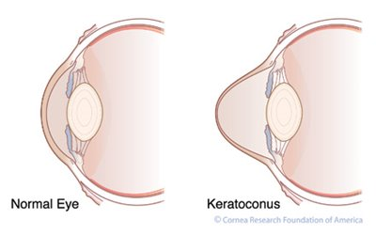
The cornea is the clear round, dome shaped portion at the front of your eye. When the cornea thins out and bulges like a cone becoming irregular in shape, it is called Keratoconus. Early in the disease, it causes slight blurring, glare, and light sensitivity. In later Keratoconus, besides protrusion of the cornea, striae or wrinkles of the posterior cornea and superficial scarring of the anterior cornea are common. Corneal hydrops, or marked swelling of the cornea, may occur yielding severe haziness, resulting in impairment of vision and discomfort.

In Keratoconus, it is the irregularity of the normal shape of the cornea that causes problems. As the disease progresses, the cornea continues to change shape and blurry, distorted vision is the result. Glasses and soft lenses can no longer provide adequate vision. Rigid gas permeable lens covering the cornea give a regular shape often correcting vision. However, in advanced cases, a cornea transplant is necessary to restore healthy vision.

Like Keratoconus, there can be irregularities in our spiritual life that cause distorted vision leading to long term spiritual vision loss. Irregular time for prayer causes irregularity of our spiritual vision. Christians should cast their care on God while boldly entering His throne room, knowing that the effectual fervent prayer of a righteous person is impactive (1 Peter 5:7, James 5:16, Hebrews 4:14-15). Like any relationship, communication is important. This is how we talk to God. How would you feel if your spouse/child/parent did not speak regularly with you?

Irregular time for Bible study and meditation on God's word causes irregularity of spiritual vision. It is a shame when one can study a secular subject with due diligence but treats God's word with superficiality. Christians should be regular and diligent in Bible study for it is profitable in our spiritual walk (2 Tim 3:16). Moreover, we should also spend time thinking and meditating on God's word. This requires regularity with a planned time and place (Psalm 1:2).

Irregular attendance of worship services and Bible studies at the congregation causes irregularity of spiritual vision (Hebrews 10:25). In Keratoconus, in a relatively new procedure, the fibrils of cornea are crossed linked to give the cornea strength. Worship is about God, but it benefits us in connecting and strengthening us to fellow children of Light who are also trying to go to heaven. It allows us to be fueled up to again go out and share the Gospel. It is easy to break a single dow rod, but put several together for so much more strength (Ecclesiastes 4:12). Besides worshipping God, attending Bibles studies and worship grow us in faith.

Christians need to be regular in prayer, Bible study and mediation, and attendance. Persistence in these allows one to see eternity more clearly. Neglecting our spiritual health can result in an irregularity leading to a form of spiritual Keratoconus and even spiritual blindness.

